 | The CAMECA IMS Software  user’s guide  WinImage V 1.0  45 610 688 – Type 108 – Indice B-
0000.doc

Contents
1 Introduction 3
1.1 Overview 3
1.2 ROI (Region of Interest) 3
1.3 Activating WinImage and opening an image file 4
2 Images Display 7
2.1 Displaying Images 7
2.2 Displayed Images details 11
2.3 Improving Image Display 12
3 Process tools 13
3.1 Accumulation 14
3.2 Rej-Sat 15
4 ANALYSIS 16
4.1 ROI 16
4.1.1 Working with ROI 16
4.1.2 Drawing ROI 17
4.1.3 ROI Properties 18
4.1.4 Grouping ROI 19
4.1.4.1 Group 19
4.1.4.2 Ungroup 24
4.1.4.3 Reset ZOrder 24
4.2 Data correction 27
4.3 Area Ratio 28
4.3.1 Introduction 28
4.3.2 Area Ratio main panel 28
4.3.3 Defining Ratios 29
4.3.4 Results panel 31
4.3.5 Details 33
4.4 Depth Profile 34
4.4.1 Introduction 34
4.4.2 Depth Profile main panel 34
4.4.3 Defining Species 35
4.4.4 Results panel 36
4.5 LineScan 38
4.5.1 Introduction 38
4.5.2 LineScan main panel 38
4.5.3 Defining Species 39
4.5.4 Results panel 41
4.6 Exporting data To Excel 43
4.6.1 Exported results: Area Ratio 45
4.6.2 Exported results: Depth Profile 46
4.6.3 Exported results: LineScan 48
Content

Introduction

Overview
WinImage is a software purposed to process images recorded with all the Cameca SIMS instruments: IMS4f, IMS6f et IMS7f, IMS1270 et IMS1280, Nanosims. WinImage can be installed on any personal computer using systems Microsoft® WindowsXP® and Microsoft® WindowsNT®.
A Cameca SIMS image file, resulting from an image analysis or previous WinImage processing saved, is expected to contain NxM images, where N is the number of analysed species, every species being characterized by one atomic mass selected by the mass spectrometer, and M is a number of cycles.
The header file contains some other data related to the instrument and the analysis conditions.
- Raster size
- Detector type (EM/RAE/CCD). In the case of multi-collection instrument, the EM number.
- Counting time per pixel
- Correction parameters (Yield Y_{EM}, dead time dt, background signal bck), as they are stored in the instrument, at the analysis time.

Image acquisitions are recorded according to the hereunder timing:
- 1st cycle: M image acquisitions corresponding to M different masses. Images are numbered from 1 to M
- 2nd cycle: M image acquisitions corresponding to M different masses. Images are numbered from M+1 à 2M.
- …
- Nth cycle: M image acquisitions corresponding to M different masses. Images are numbered from N*M-(M-1) à NxM.

Within a cycle, acquisition may have been run either in a sequential mode, a single mass at the same time, that is the so-called monocollection case, or in a simultaneous mode, all the masses at the same time, that is the so-called multicollection case which can be considered only if the instrument is equipped with a multicollector.

Original image files (*.im) are never modified. If the image processing generates new data (e.g. cycle accumulation), a new file is created and saved with an ".imp" extension.

ROI (Region of Interest)
Within every image, WinImage allows to define ROI (Region Of Interest), i.e. set of pixels in order to process Analysis with respect to these different ROI. Several ROI can be grouped.

Content

Activating WinImage and opening an image file
wimim.exe is automatically installed in the directory :

When activating WinImage, Load is the single available button in the hereunder window:
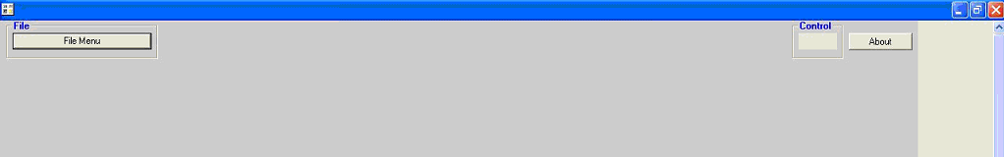

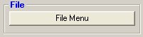 | Clicking the FileMenu button will cause the opening of the File Menu shown as hereunder.
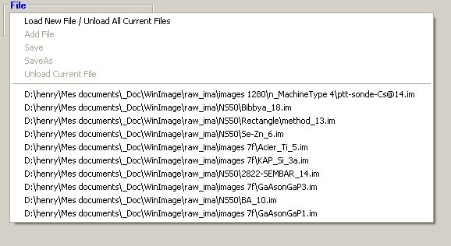 | Clicking Load New / Unload All Current File allows to open the file explorer window. Files are of type *.im or *.imp.  After the first Load, using the  Load New / Unload All Current File command will cause the unload of previously loaded files.
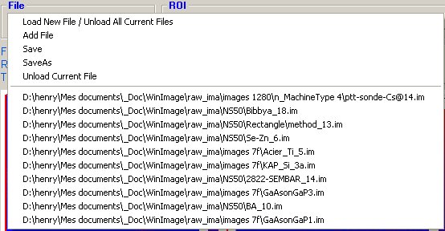 | After the first Load, clicking Add File makes possible to load other files with the same image size, without unloading the files in use.  Save and Save As command allow to save the current file with its modifications (e.g initialized LUT, or Process results ).  Unload Current File will unload the current file.
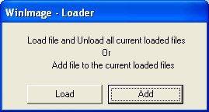 | After the first Load, selecting a file among the More Recent Used Files list opens the opposite box which proposes to select Load or Add.  Load is equivalent to Load New / Unload All Current File.  Add is equivalent to Add File.
Content

Once a file is selected the “File Explorer” Windows is opened.
The window allows to select which species and which cycle to load.

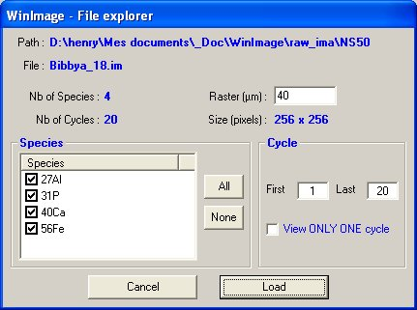 | - File species are displayed in the right hand side window.  - The operator may select the species he plans to work with, and the working cycle interval [first, last] as well  - Validating these paramaters can be achieved by clicking the Load button.  - Checking the View Only ONE cycle checkbox allows to display selected species images at the same cycle.  - Raster size can be modified, if necessary in the editing field Raster (µm).

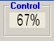 | Once the Species and cycles to load had  been selected and the button “Load”  of the “File Explorer” had been clicked, WinImage start to load the images.  WinImage displays a progress window (this task may last a few minutes).
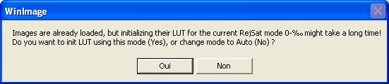 | After having loaded the images, WinImage proposes to preprocess them to allow further quicker responses This is particularly recommended whenever the current Rej-Sat display mode is :  “0 – X %0”.  As this initialization task may last a few minutes, the user is asked to confirm this initialization.
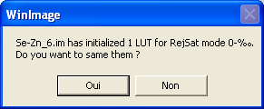 | Note : If the images have been initialized for the “0 – X %0” Rej-Sat mode, it is possible to save this initialization before unloading the file in order to reload it quickly later on.

When all images had been loaded and preprocessed, WinImage displays its main window.
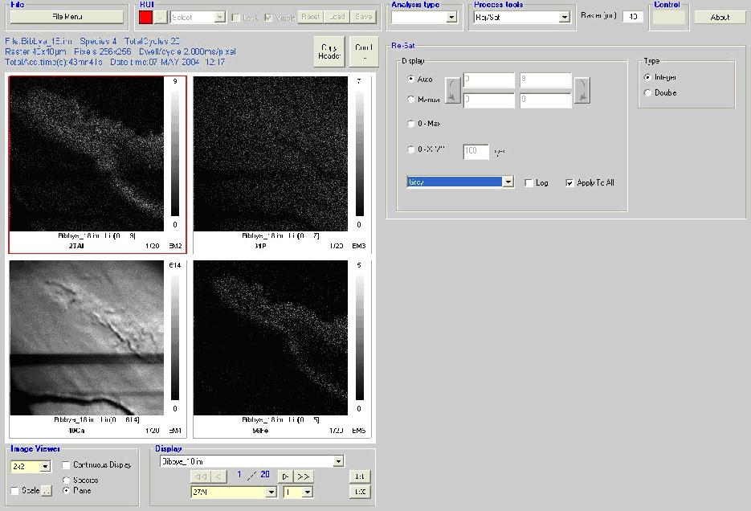

This main window has two parts :
- The left part is used to display the images of the loaded files. It also offers ways to sort them by species or by cycles and to navigate thought them.
- The Right part offers tools, such as “Rej-Sat” to custom the image display, Analysis on the images such as “Depth Profile”, “Linescan” or “Area ratio”, and process on the images such as “Accumulation”.
Content

Images Display

Displaying Images

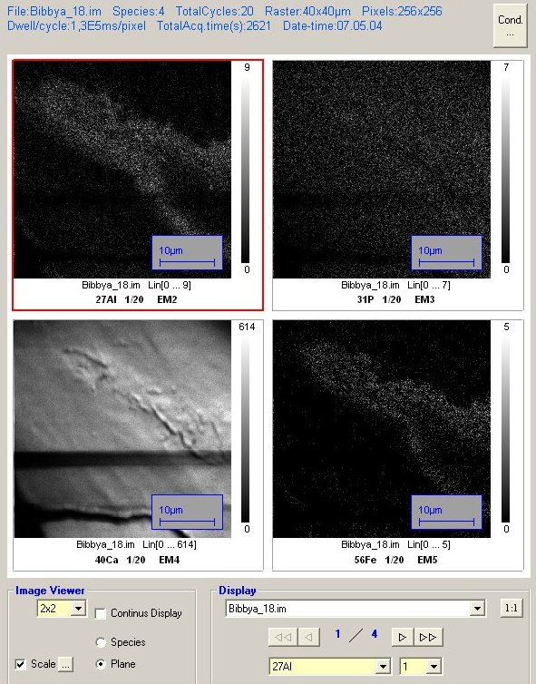

The current image has red bold border.

The properties of the image currently selected are shown in the text that is upper the images :

 | The Copy Header button copies the properties of the image currently selected to the clipboard to be able to paste them to documents of other applications such as Microsoft® Word®.

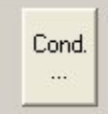 | The Cond. button opens a “Condition” window that displays all the information of the current image’s file.
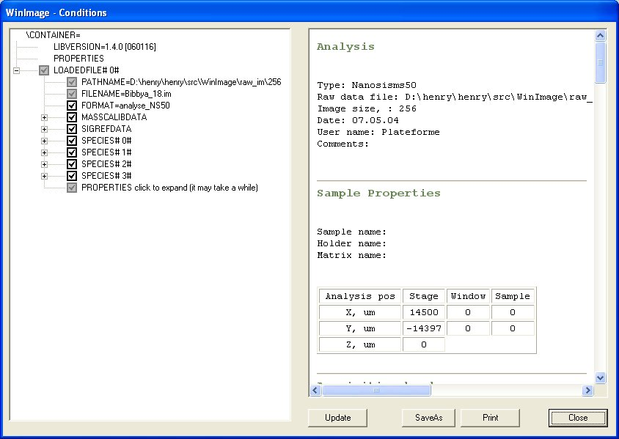 | The “Condition” window allows navigating through the data’s tree to consult values and to select/unselect values that will be used to create the Analysis condition summary displayed on the right part of this window.  These Analysis condition summaries can be printed and saved to an html file.

Images can be displayed according to three size : 1 per page, 2 x 2 per page or 4 x 4 per page by selecting :
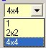

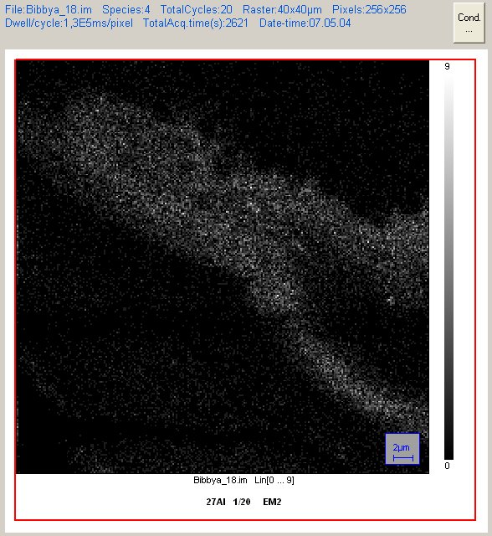 | 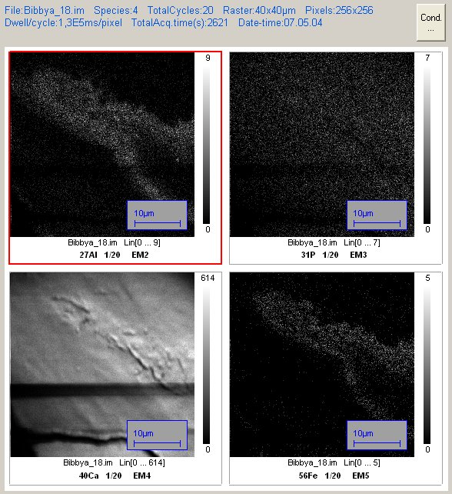 | 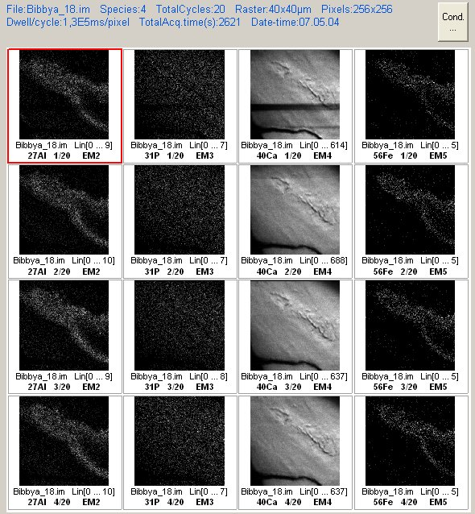

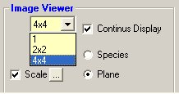 | - Check box “Continus Display” :  - If not checked, only the current species or the current cycle is diplayed, according to the radio button “Species” / “Plane” currently selected.  - If checked, all the images are displayed  - Radio buttons “Species” / “Plane” : sort the images by species or by plane  Note that with all the boxes of this software, once activated by clicking the mouse left hand side button, the mouse scroll wheel is assigned to the element -cycle or mass - scrolling, instead of using arrows or numerical editing fields.
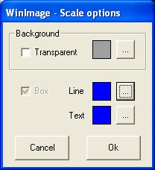 | - Check box “Scale” :  - If not checked, no scale information are displayed onto the images.  - If checked, scale information are displayed onto the images if size is 1 image per page or 2 x 2 images per page.  The button close to the “Scale” check box opens the  “Scale options” window that allows to change the scale display parameters.

The Display frame is used to navigate through loaded images.
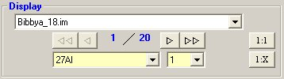

 | Select for display the current file or data resulting from previous process. (data not yet saved are marked with a star "*").
 | Shows, and allows to select the current species and current cycle of the current file.
 | Goto the first page of the current file
 | Goto to the previous page of the current file
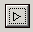 | Goto to the next page of the current file
 | Goto to the last page of the current file
Shows the current page number and the number of pages of the current file.

The left number, indicating the current page, can be entered using the keyboard after it had been selected by the mouse.

The right number, indicating the number of pages of the current file, depends upon the sorts choices : “Species” or “Plane” and either “Continus Display” is activated or not.
 | The 1:1 button resets the zoom factor to 1:1 to all the images of the current file if there is only one loaded file, or to all the images of the current file or to all images of all loaded files depending on the user selection.
 | The “1:X” button applies the same zoom factor as the current image either to all the images of the current file if there is only one loaded file, or to all the images of the current file or to all images of all loaded files depending on the choice of the user.
Content

Displayed Images details

Rolling the mouse wheel over the current focused image, zoom in/out the current the image.
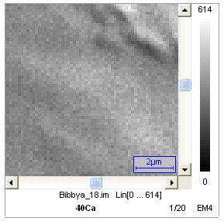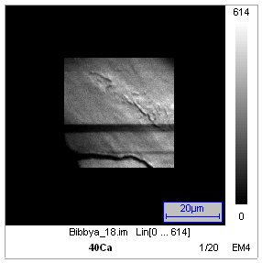
Clicking the right button of the mouse over the current focused image opens the popup menu as hereunder.
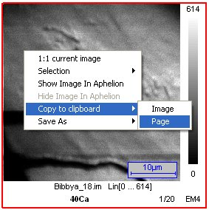
Menu item : “1:1 current image” | Restore to “1:1” the current image zoom factor
Menu item : “Grouping” | This item will be discussed later with the ROI chapter
Menu item : “Show Image In Aphelion” | (*) Show the current image in Aphelion. This is usefull to process every operator provided by Aphelion.
Menu item : “Hide Image In Aphelion” | (*) Hide the current image in Aphelion.
Menu item : “Copy to clipboard” | This command copy to clipboard the current Image or current Page depending the user choice’s. The clipboard can be copied to software such as Microsoft® World®
Menu item : “Save As”  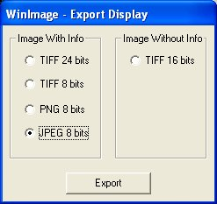 | This command opens the “Export display” window.  The “Export display” window allows to chose the file’s extension and quality to save the current Image or current Page - depending the user’s choice - to a file.
(*) Avalaible only with Aphelion®

Improving Image Display
To improve the rejection and saturation of displayed images, select Rej-Sat into the Process tools list box
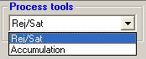 | Selecting Rej-Sat into the Process tools list box will show the Rej-Sat frame as hereunder.
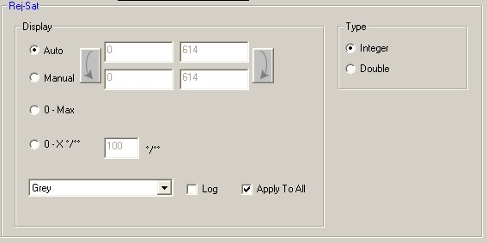
The Rej-Sat frame offers different choices to manage the images rejection and saturation display.
- Apply to All : If checked, changes will be applied to all the images of all the file currently loaded. Otherwise changes are only applied to the image currently selected
- The list box allow to select the LUT
- The Log check box is used to represent the LUT using a Linear or Logarithmic scale.
- Type : The selected Integer or Double format will be used for processing the pixel values.
Pixel values smaller than Display Mini will be displayed as Display mini. Pixel values larger than Display Maxi . Different display mode can be seleted:
- Auto :
  - Display Mini is set to the minimum image pixel value.
  - Display Maxi is set to the maximum image pixel value.
- Manual :
  - Display Mini is set manually by the user.
  - Display Maxi is set manually by the user.
- 0 – Max :
  - Display Mini is set to zero.
  - Display Maxi is set to the maximum image pixel value.
- “0 – X %0” use :
  - Display Mini is set to zero.
  - Display Maxi is a computed according to the saturation value - X per thousand - entered by the user.
  - Ex : If the user enters 10, WinImage computes – for this image - what is the maximum saturated value whith must be applied to ensure that 10 per thoushands pixels of the images will be beyond this computed value.
Content

Process tools

WinImage process tools activation result in the creation of a new file (*.imp) that can be loaded by WinImage.

2 different processing can be selected in the list box: Accumulation and Rej-Sat.

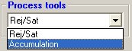

Content

Accumulation
Accumulation process is used to accumulated cycles from a same species. It results one image per species processed.

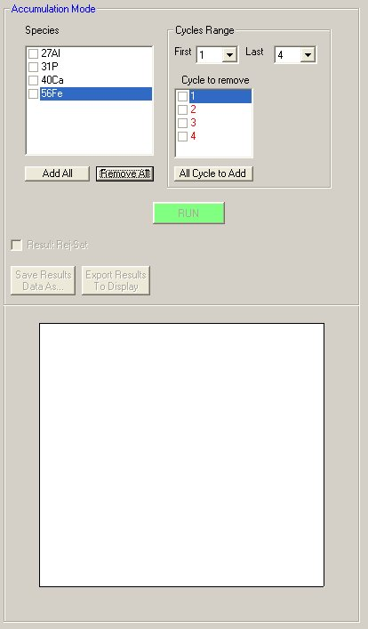 | The “Accumulation Mode” frame allow to select Species, and cycles to accumulate for the current file.  You have to check the species you want to accumulate.  You have to define the first and last cycle of the accumulation. It is possible to remove cycles between these first/last cycles.  Then click the “RUN” button.  While processing the accumulation, the “RUN” button changes to an “ABORT” button that allow to abort the process.  The progress of the process is shown into the top-rigth “Control” frame as shown hereunder.  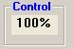

Once the accumulation had been processed, the result images are displayed.

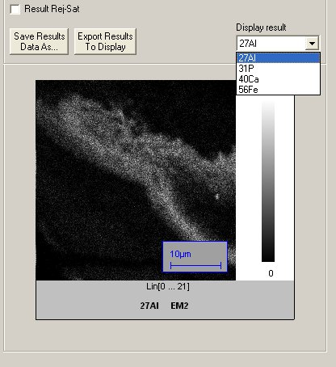 | It is possible to choose the species to display between then different species processed using the “Display result” list box or the activated mouse scroll wheel.  The Result Rej-Sat check box is used to show the “Accumulation Rej-Sat” frame.  This frame allows changing the rejection and saturation parameters of the Accumulation results.  To hide the “Accumulation Rej-Sat” frame, uncheck the “Result Rej-Sat” check box.
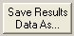 | The “Save Results Data As …” button opens a “Save As” window.  Uses this button to save the results as an independent Cameca “.imp” file.  These files contain the parameters as their original file can be therefore loaded with WinImage. One the other hand, the number of cycle and different time’s values are updated.  These file can be loaded with WinImage.
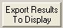  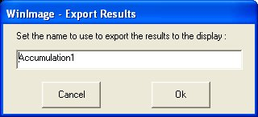 | The “Export Results To Display” button exports the result images to the display part of the main window. These results are exported using a name entered by the user within the left “” window :  Warning : Not all parameter will be associated to theses images, and the “Cond.” button used to see the parameter won’t be enable.  To get all the parameters, prefer “Save Results Data As …” and load the saved file.

Rej-Sat
For useful information concerning the Rej-Sat process, refer above to the sections § Activating WinImage and opening an image file and § Improving Image Display.
Content

ANALYSIS

ROI
WinImage provides process tools on images such as Accumulation, but WinImage main’s capability is to analyse DepthProfile, LineScan or Area ratio from Cameca images files.
Such analysis are processed on parts of images, called ROI (Region of Interest ).

DepthProfile and Area ratio ROI are compatible, while LineScan analysis ROI of are not compatible with the other analysis.

Working with ROI
Playing with the ROI requires to select an Analysis type in the Analysis type list box.

ROI can be drawn on the images, saved to dedicated .tks files and loaded using the ROI frame
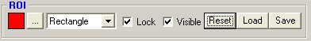

The List box allows to select the cursor action on the images. The list changes depending on the current analysis type.

 | Selection of the current ROI colour: Either the proposed colour or any other colour available after clicking the “…” button.
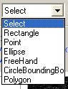 | The Select item of the list box is used to select ROI onto the images. ROI can be selected either by clicking the left button over an ROI with the mouse (using Ctrl key add ROI to the current selection ) or selecting all ROI within a rectangle. To select all ROI within an area, click down the left button of mouse, move the mouse and release the button.  Other items (Rectangle, Line, Point … ) are used to draw the corresponding shape onto the images.
 | Lock check box is purposed to draw successively shapes of same type.
 | Visible check box is purposed to Show/Hide the ROI drawn in the images.
Save button opens a Save As window to save the ROI drawn onto the images to a “.tks” file
Load button opens a Open window to select a *.tks file containing ROI.
Reset button remove all the ROI drawn onto the images.

Drawing ROI
For drawing a ROI, select the kind of shape in the ROI list box (rectangle/ Point/ Ellipse/ Free Hand/Circle Bounding/ Polygon).

After drawing a shape, a number is automatically associated to the ROI and the list box goes back to the “Select” item if Lock is not checked. This allows to select the number and to move it - with the mouse - to an appropriated location on the images.
By selecting the shape it is possible to adjust it to.
Otherwise, if Lock is checked the user can directly draw an other shape of the same type.
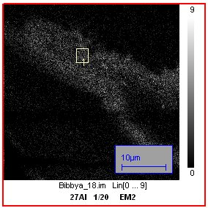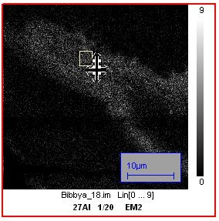

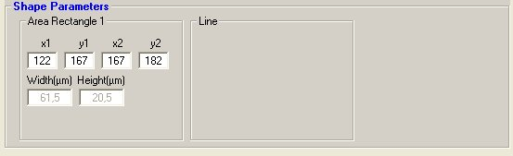  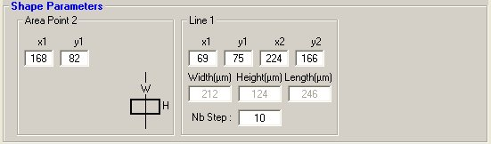  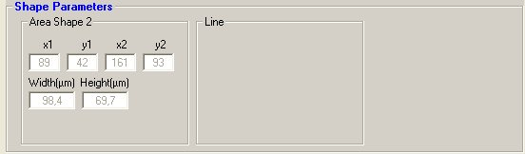 | When a shape is selected, shape’s type, number, size and position are displayed into the analysis frame. Line, Point and Rectangle shapes can be adjusted using the text box.  Corrects value are :  [ 0 ; image size – 1]  For rectangles, positions are include into the shape !  Ex :  X1 = 100, Y1 = 110,  X2 = 100, Y2 = 110.  Nb pixels = ( 110 – 100 + 1 ) * ( 110 – 100 + 1 )  = 121 pixels

To delete an ROI, select it (or its number) and press “Del” key.

ROI Properties
When ROI are selected, it is possible to change their properties by using the mouse right hand side button to select the command ROI/Properties that opens the ROI Properties window.
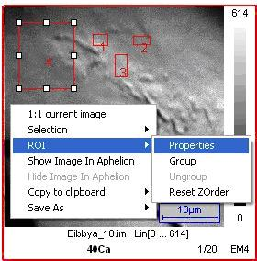

If multiples ROI are selected when the ROI Properties window is opened, each selected ROI will be affected by the modifications that will be achieved.

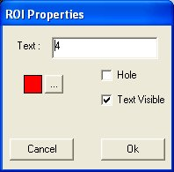

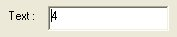 | Edit the text which must be displayed for this ROI
 | Selection of the current ROI colour: Either the proposed colour or any other colour available after clicking the “…” button.
 | Text Visible check box is used to Show/Hide the ROI text.
 | Hole check box will be discussed in the next section § Grouping ROI.
Content

Grouping ROI

Group
Shapes can be grouped. Grouping shapes allows to use customized ROI consisting of several outbound shapes and also to define "holes" inside outbound shapes. Holes of an ROI are area of the image that won’t be taken in account for analysis.

WinImage enables to define customized ROI with holes. The ROI is then made with at least 2 shapes. The first one defines the outbound of the ROI, the other define holes - that will not be processed - inside the first shape.

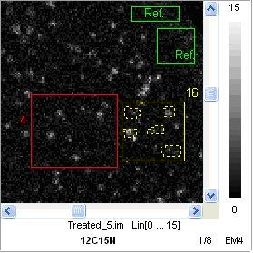
Outbound
( solid line )
Holes
( dash line )

Check the Selection mode of the “ROI” list box is selected.
Then, draw a selection rectangle including shapes to be grouped - as shown hereunder - or select successively shapes with the ctrl key and the mouse left hand side button.
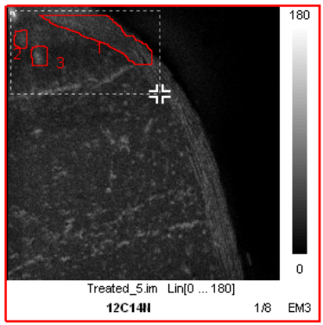

Ex 1 : Creating a group, changing both the colour and the text
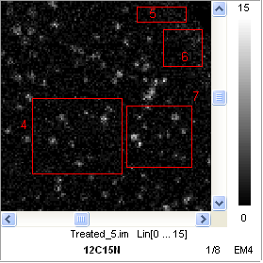 | Starting status

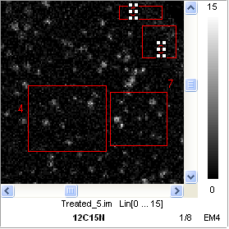 | Select rectangles 5 and 6.  Open the image popup menu and select : ROI / Group

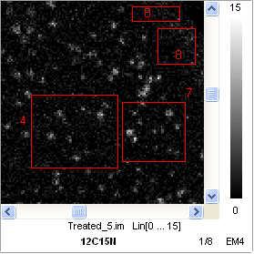 | The rectangles 5 and 6 are grouped as a new shape : 8

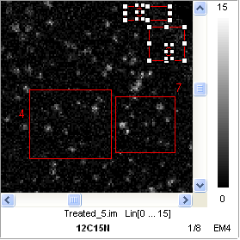 | Select the new shape 8.  Open the popup menu of the image and select : ROI / Properties  Change the colour to Green  Change the Text to Ref.  Valid with Ok.

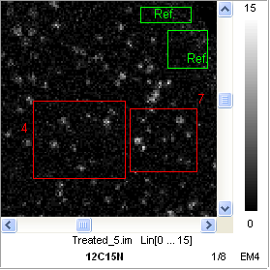

Ex 2 : Creating a shape with holes.
Starting status

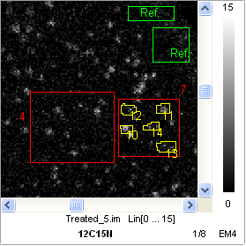 | Select, for example, the type of shape Free hand from the ROI list type, and draw new shapes within the rectangle 7

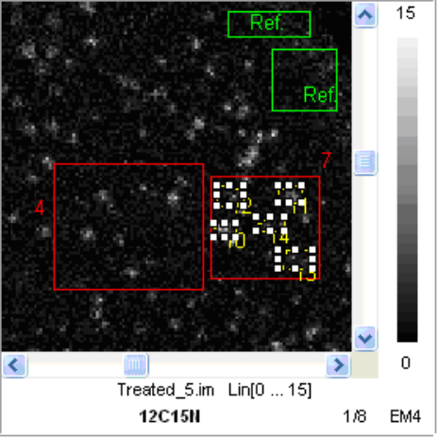 | Select these new shapes  Open the popup menu of the image and select : ROI / Properties  Check the Hole check box.  Uncheck the Text Visible check box.  Valid with Ok.

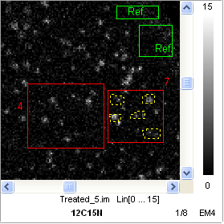

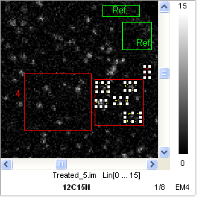 | Select the holes and the rectangle 7.  Open the popup menu of the image and select : ROI / Group

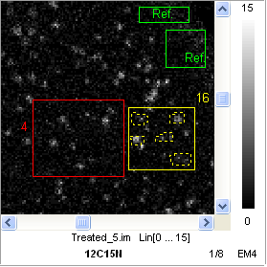

Ungroup

To ungroup shapes : select them, open the popup menu of the image and select ROI/Ungroup

Reset ZOrder

ROI uses ZOrder (Front/Back...). When a new ROI is drawn, WinImage set the new shape ZOrder depending upon the existing one.

A ) If the new shape is drawn completely within a ROI, this new ROI is put on Front Zorder. This makes its selection easy.

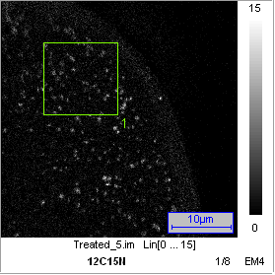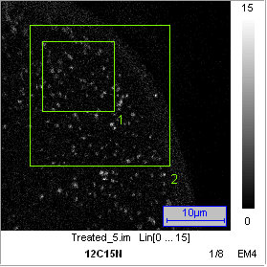

If the new shape overcoats an older ROI, the older ROI is moved on Front Zorder. This makes possible to select the older ROI.

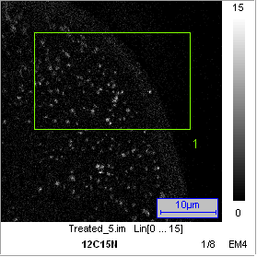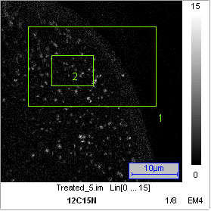

In last two cases there is no problem to select any ROI.

An issue may arise in the following case :
- The user has drawn a first small ROI, and after he has drawn a second ROI - that is not over the first one but that is larger than the first one -, and then the user moves the second ROI other the first one: The last drawn ROI is then masking the first ROI and it is no more possible to select the first ROI.

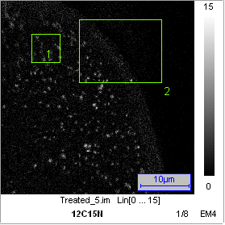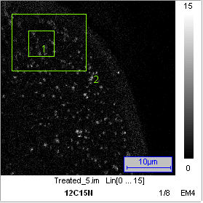

The solution to this problem consists of (i) selecting the larger ROI, (ii) opening the popup menu and (iii) selecting ROI Reset ZOrder. Then the ROI ZOrder are then modified conveniently.
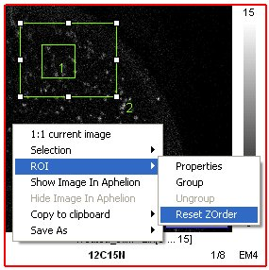

Remarks:
- Shapes of a same group must not overlap.
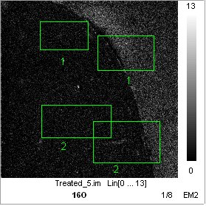
Correct
Error

Holes of a same group must not overlap.
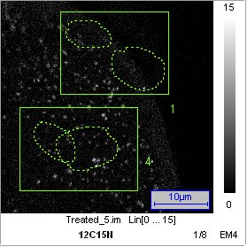
Correct
Error

Holes must not extend through their shapes.
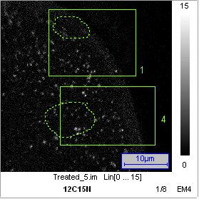
Correct
Error

Content

Data correction
When counting particles, it is classical to consider the corrections of yield correction (Y_{EM}), dead time (dt) and background (bck) for Electron Multiplier and background (bck) for Faraday Cup. Refer to the Ion Optics user's guide.

EM : 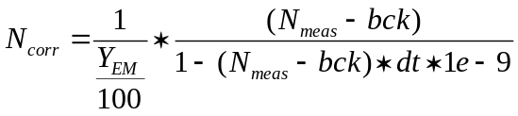

FC : Ncorr = Nmeas – bck

Nmeas and Ncorr are in c/s

It is possible to correct measured data before processing Depth Profile, LineScan or Area ratio analysis.
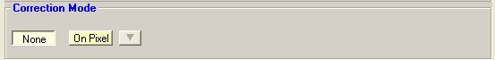 | No correction : Y_{EM}=100% ; dt = bck = 0.  When « On Pixel » is selected, corrections are applied.  opens the Correction table.
Correction window  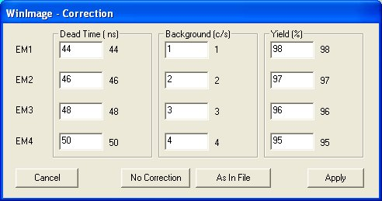 | The program takes into account correction parameters which can be edited in the Correction window, independently for each detector in use.  For each parameter, a text box is used to edit the current correction. The second value is the one stored when the file had been acquired.  The « As In File » restores the parameters as they are contained in the acquisition file, i.e. as they were in the instrument setup at the analysis time.  These file parameters are therefore transferred in the correction table.  Y_{EM}=100% ; dt = bck = 0.  Set the parameter to no effects.  validates the correction table data

Content

Area Ratio

Introduction
The Area Ratio analysis is targeted to compute for a given zone signal ratios between different species. Additionally, this application makes it possible to organize the full set of cycles into blocks. Blocks are subsets of the cycles which are defined in the analysis. All the blocks of a same analysis contains the same number of cycles.
Note that the computed species ratio may be Isotope ratios, but in the general case, the Area Ratio processing can be considered for applications different of Isotope ratios.

Area Ratio main panel
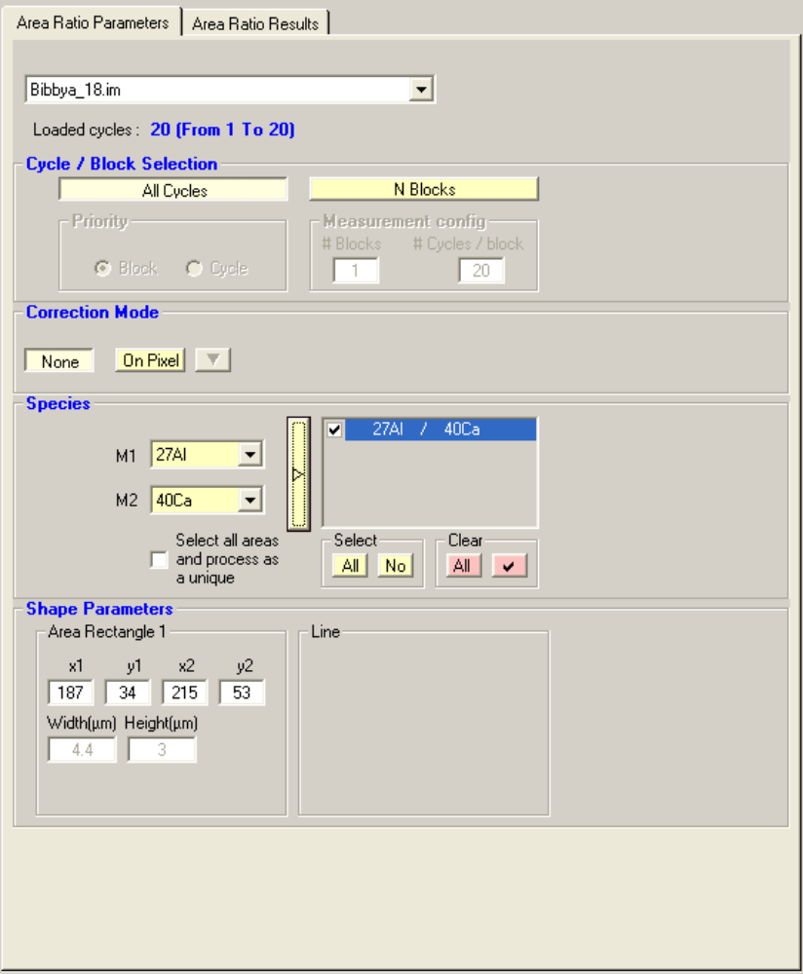 | Area ratio main panel  The Area Ratio panel is opened at the right hand side of the main window as soon as Area Ratio is selected as analysis type.

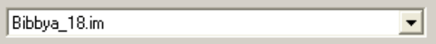 | Select the analysis file to be processed.

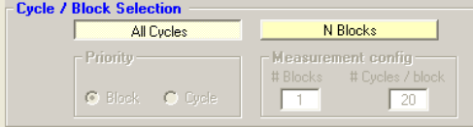 | A single block consists of all the cycles.
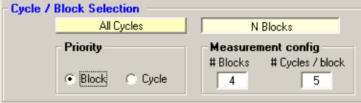 | Selecting “N Blocks” mode :  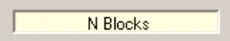  Allows to edit the number of blocks (# Blocks) and the number of cycles per block (# Cycles/Block). See below, Priority.

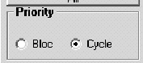 | Priority  Cycle Whenever the operator edits a number of blocks and a number of cycles/block corresponding to an overall number of cycles larger than available, then the number of blocks is computed according to the number of cycles/block.  Block Whenever the operator edits a number of blocks and a number of cycles/block corresponding to an overall number of cycles larger than available, then the number of cycles/block is computed according to the number of blocks.

Defining Ratios

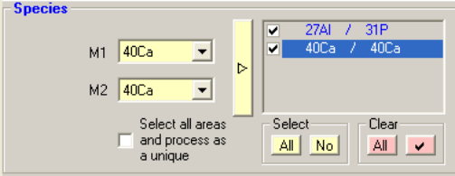 | Computed ratio will be M1/M2  Both combos propose the analysis file species.  Clicking the yellow button validates the ratio.  The ratio is then displayed at the right hand side.  It is possible to define an unlimited number of ratios, A checkbox is also displayed close to every ratio. It is possible to unchecked the checkboxes. Every checked ratio will be computed.  Select  Checks automatically all the checkboxes.  Uncheck automatically all the checkboxes.  Clear  Deletes all the ratios.  Deletes all the checked ratios.
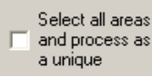 | Each ratio M1/M2 generates analysis results for each shape selected at analysis run time.  The “Select all areas and process as a unique” check box allows to consider all selected shapes at analysis run time as a single one, generating only one result per ratio.

To run an analysis, verify that:
- At least one ratio is defined and checked.
- At least one shape is selected or the “Select all areas and process as a unique” is checked.

Results panel

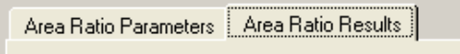 | The Area Ratio Results panel displays the results.

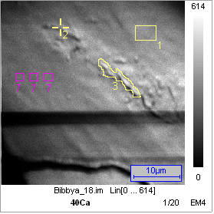 | In this exemple the Point number 2, the Freehand shape number 3 and the group of rectangles number 7 are selected.

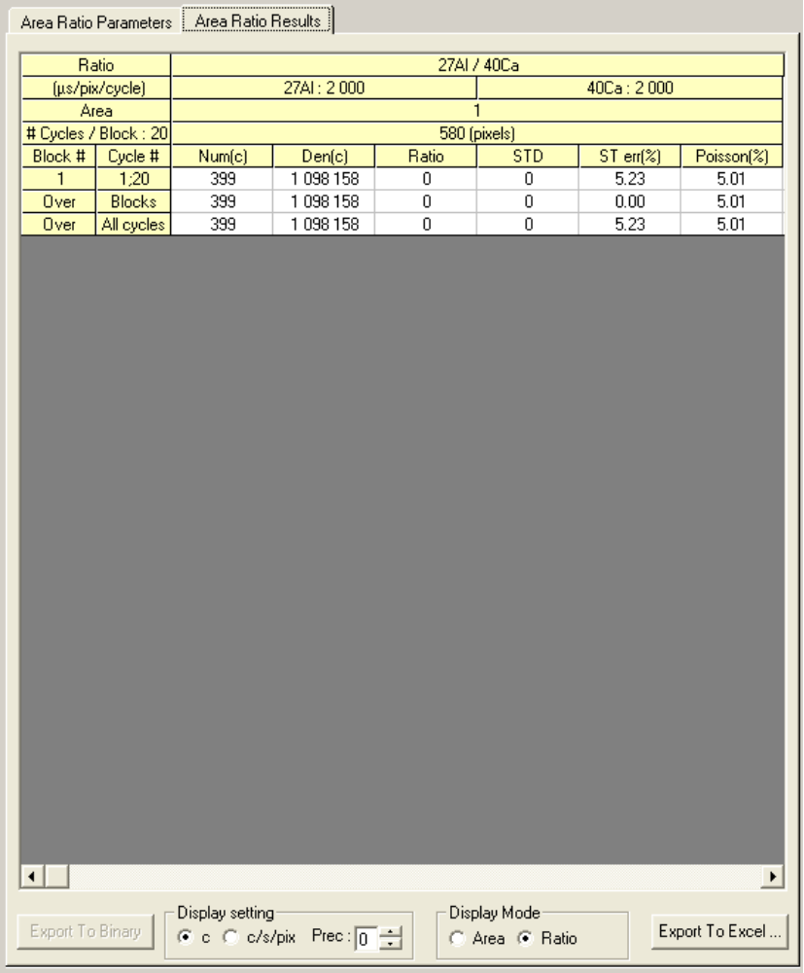 | It provides The M1/M2 species, their counting time per pixel, the zone number for each aera analysed, the number of pixel per area.  “Num. counts” is the sum of counts per block for M1 species.  “Den. counts” is the sum of counts per block for M2 species.  Uses the horizontal scrollbar to scroll areas and ratios results.

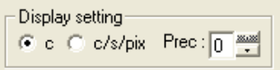 | Use the Display Setting ckeck box to select how the pixels must be expressed: "counts per pixel" (c) or "counts per second per pixel" (c/s/pix).  Edit Prec to set the number of digits
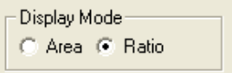 | Display Mode is purposed to select the sorting mode of the data in the spreadsheet: per Area or per Ratio.
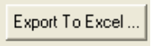 | Results can be exported to Microsoft® Excel® using the Export To Excel button.  See the Section § Exporting Data to Excel.

Details

- Ratio: Average ratio, computed over the block, with correction if the option is selected.
Intensities are firstly corrected per pixel.
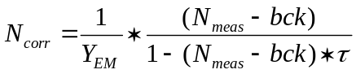
The Ratios are then computed over the corrected Intensities , integrated over all the zone pixels and the block cycles.
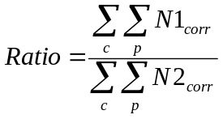

Where 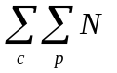 means the summation over the block and over the Zone.

- µs/pixel is the counting time per pixel as it will be taken into account in the Poisson formula.
- Ratio-Cycles is the Ratio calculated for each block cycle.
- STD is the ratio spread over one block, calculated by the XLS STDEVA XLS function (Sample Standard Deviation)
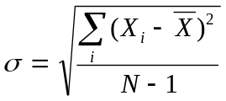

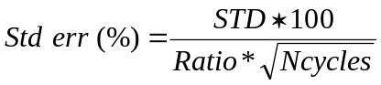
Where Ncycles is the number of cycles per block.

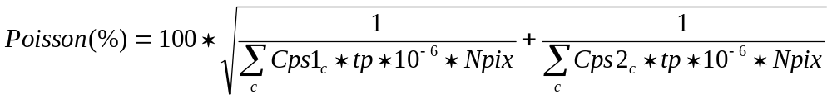

Where Cps1 et Cps2 are the average intensities of, respectively, numerator mass M1 and denominator mass M2 raw data, Npix is the number of pixels per zone and tp the counting time per pixel, in µs.

Content

Depth Profile

Introduction
The Depth Profile analysis is targeted to count signal through cycles for a given zone.

Depth Profile main panel

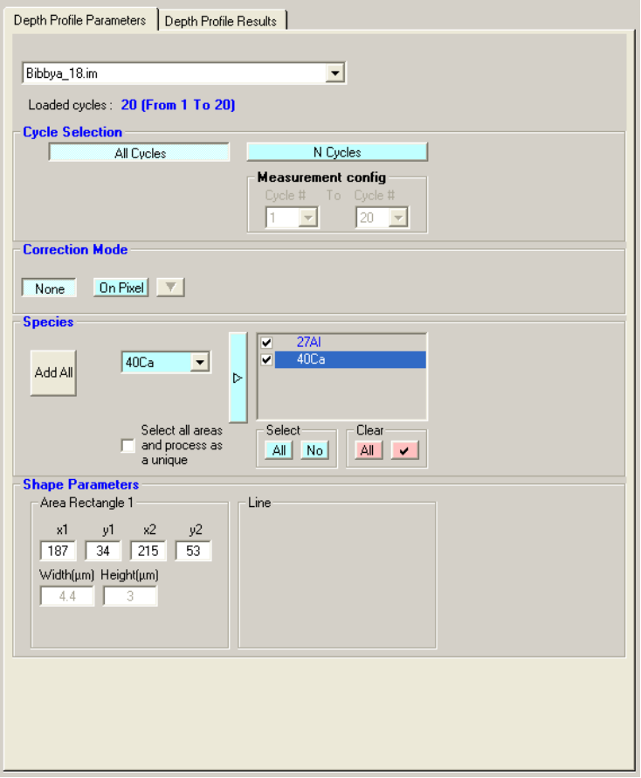 | Depth Profile main panel  The Depth Profile panel is opened at the right hand side of the main window as soon as Depth Profile is selected as analysis type.

 | Select the analysis file to be processed.
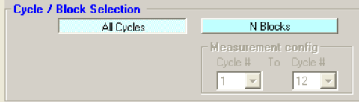 | 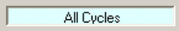  “All cycles” mode run an analysis through all loaded cycles

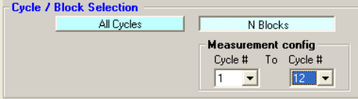 | 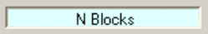  “N Blocks” mode run analysis from a Start cycle To an End cycle choosen into list box of loaded cycles.

Defining Species

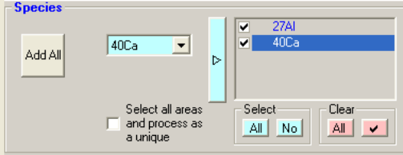 | A combo propose the analysis file species.  Clicking the blue button validates the species.  The species is then displayed at the right hand side.  A checkbox is also displayed close to every species added to the list. It is possible to unchecked the checkboxes. Every checked species will be computed.  Select  checks automatically all the checkboxes.  un checks automatically all the checkboxes.  Clear  deletes all the species.  deletes all the checked species.
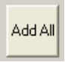 | Add all the loaded species to the list.
Each species generates analysis results for each shape selected at analysis run time.

The Select all areas and process as a unique check box allows to consider all selected shapes at analysis run time as a single one, generating only one result per ratio.

To run an analysis, verify that :
- At least one species is defined and checked.
- At least one shape is selected or the “Select all areas and process as a unique” is checked.

Results panel

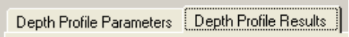 | The Depth Profile Results panel displays the results.

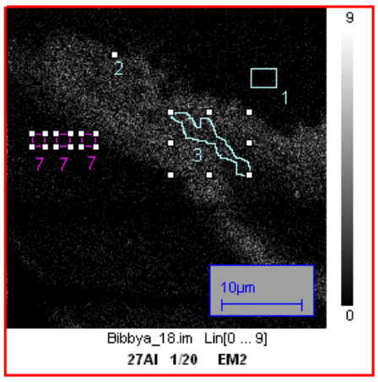 | In this exemple the Point number 2, the Freehand shape number 3 and the group of rectangles number 7 are selected.

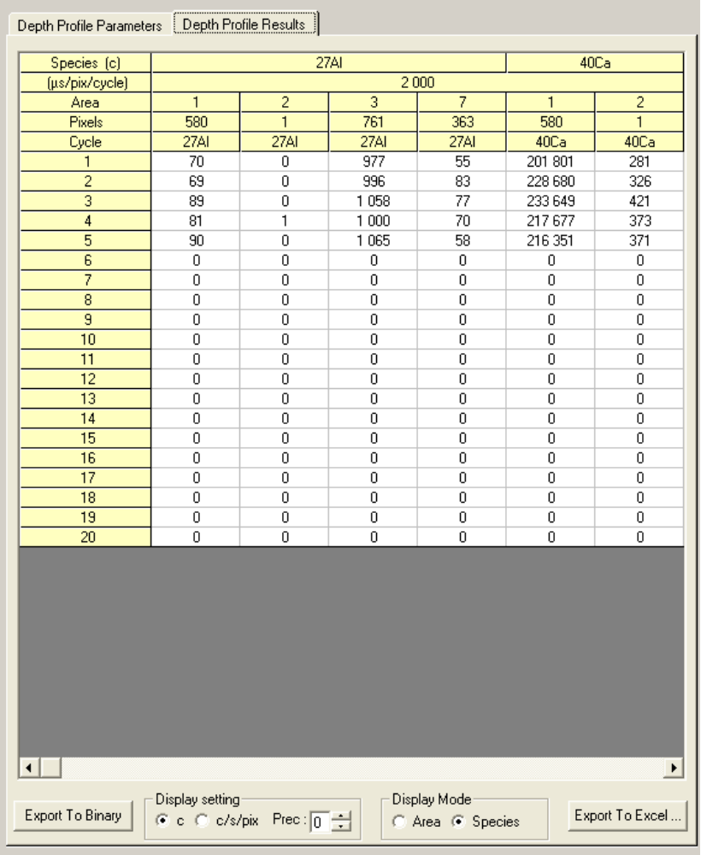 | The “Depth Profile Results” panel display the results.  It provides The species, the zone number for each aera analysed, the number of pixel per area.  Results are in : counts or in  counts/per seconds/per pixel  Uses the horizontal scrollbar to scroll areas and species results.

Use the Display Setting ckeck box to select how the pixels must be expressed: "counts per pixel" (c) or "counts per second per pixel" (c/s/pix).
Edit Prec to set the number of digits
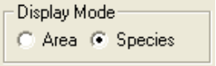 | Use the « Display Mode » to select to show the results sorted either by Area or by Species.  Display Mode is purposed to select the sorting mode of the data in the spreadsheet: per Area or per Species.
Results can be exported to Microsoft® Excel® using the Export To Excel button.
See the Section § Exporting Data to Excel
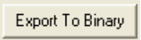 | Data can be exported to binary files.  Then theses files can be loaded to Cameca WinCurve software.  This option is not available for every Cameca image file.
Content

LineScan

Introduction
The LineScan analysis is targeted to count signal for a given zone across a line defined over the images.

LineScan main panel

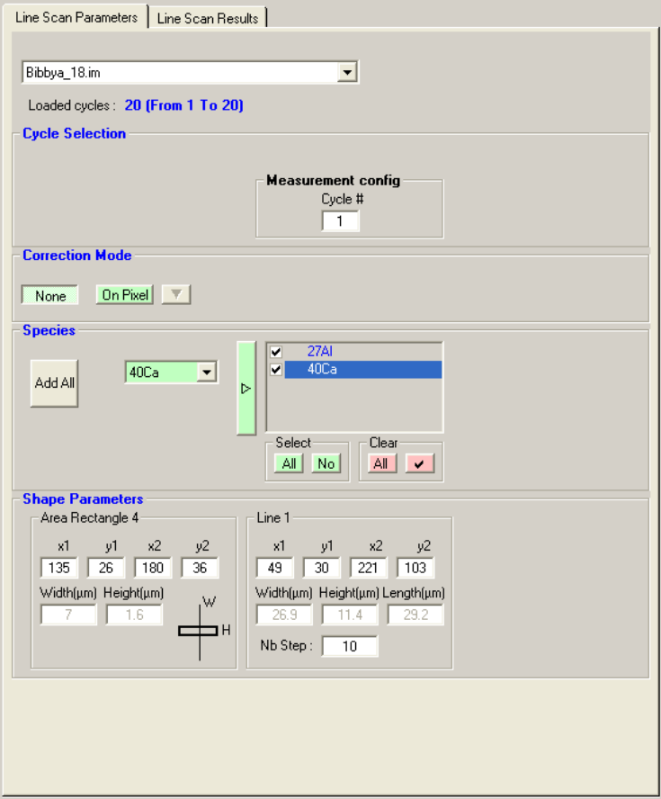 | LineScan main panel  The LineScan panel is opened at the right hand side of the main window as soon as LineScan is selected as analysis type.

 | Select the analysis file to be processed.
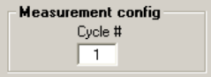 | “Cycle#” is used to indicate which cycle to process.
Content

Defining Species

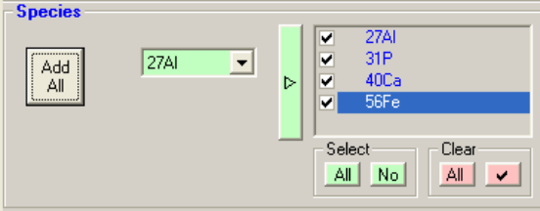 | A combo propose the analysis file species.  Clicking the green button validates the species.  The species is then displayed at the right hand side.  A checkbox is also displayed close to every species added to the list. It is possible to unchecked the checkboxes. Every checked species will be computed.  Select  checks automatically all the checkboxes.  un checks automatically all the checkboxes.  Clear  deletes all the species.  deletes all the checked species.
 | Add all the loaded species to the list.

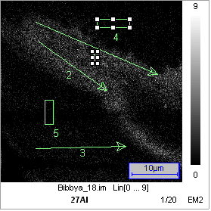  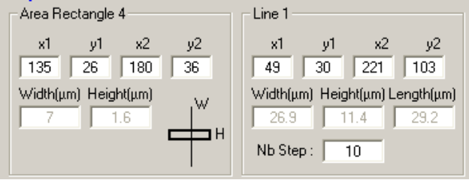 | When using a rectangle to scan the image ( i.e Rectangle 4 for this example ), the scan will move as shown into the “Shape parameter” diagram :  Width is transversal to the main line,  Height is a long the main line.

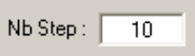 | The “Nb Step” text box is used to enter the number of step of the LineScan analysis.

To run an analysis,check that :
- At least one species is defined and checked.
- At least one shape that will be used as Scanning moving area and one line that will be used as scanning base line.

The following images show the progress of scanning Area 4 through Line 1.

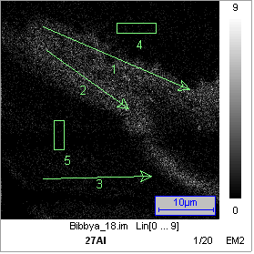

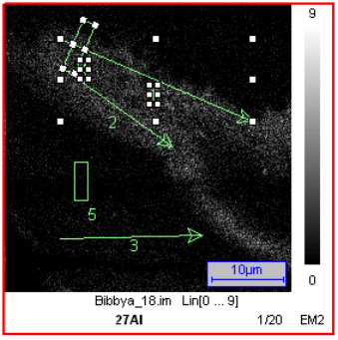 | 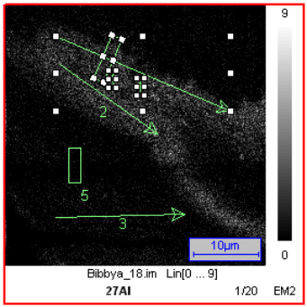 | 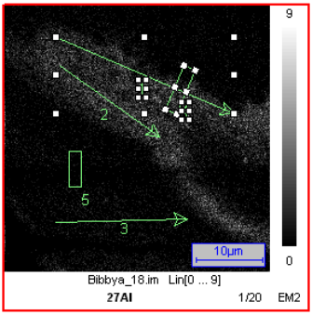 | 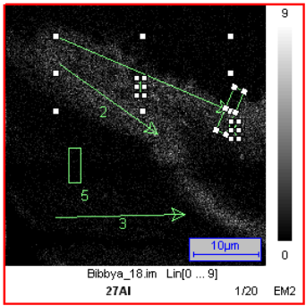
Content

Results panel

The Depth Profile Results panel display the results.

In this exemple the selected Rectangle number 4 will move across the selected Line number 1.

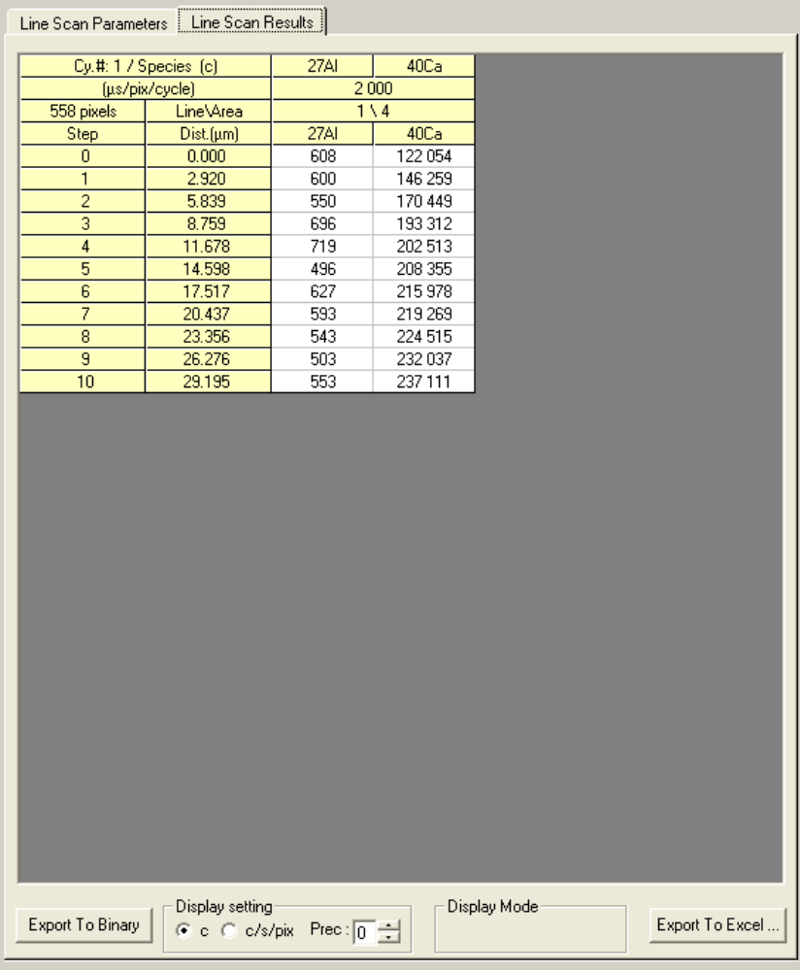 | The “LineScan Results” panel display the results.  It provides The species, the line and zone number analysed, the number of pixel per area.  Results are in :  counts/per seconds/per pixel  Uses the horizontal scrollbar to scroll areas and species results.

Use the Display Setting ckeck box to select how the pixels must be expressed: "counts per pixel" (c) or "counts per second per pixel" (c/s/pix).
Edit Prec to set the number of digits
Results can be exported to Microsoft® Excel® using the Export To Excel button.
See the Section § Exporting Data to Excel
Data can be exported to binary files.
Then theses files can be loaded to Cameca WinCurve software.

This option is not available for every Cameca image file.
Content

Exporting data To Excel
Data can be exported to Microsoft® Excel®
The Export To Excel window is opened after the button Export to Excel is clicked.

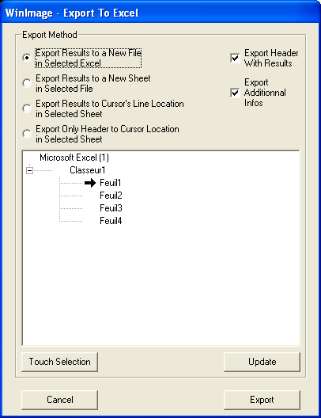

The Export method option indicates: in which file, how, where and what must be exported.

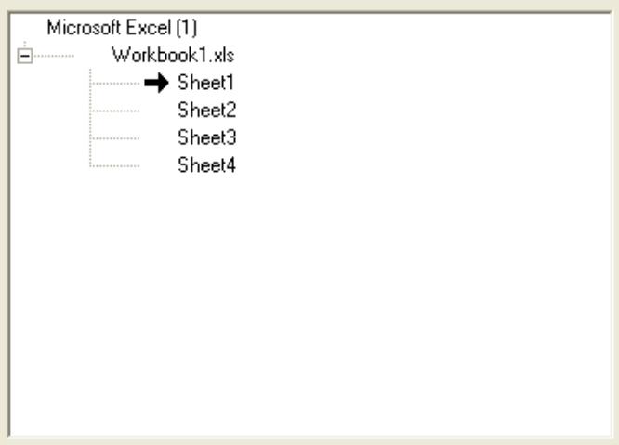 | Display the currently opened Excel® applications, with their opened workbooks and their Sheets.  The Arrow indicates the current location of the future exports , taking in account the option selected above the tree.
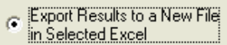 | Results will be exported to a new file into the selected Excel® application.
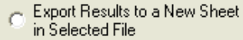 | Results will be exported to a new sheet into the selected Workbook.
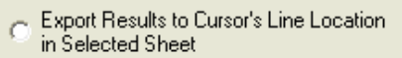 | Results will be exported to the current cursor’s line location into the selected sheet of the selected Workbook.
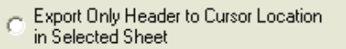 | Only header data will be exported to the current cursor location into the selected sheet of the selected Workbook.
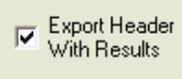 | If checked, Header data will be exported with results. Else only results will be exported.
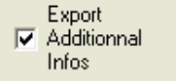 | If checked, additional analysis parameters data will be exported with results. Else only results will be exported.
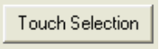 | The Touch Selection button leads to the top left corner of the current selected sheet of the selected. This is useful to set the cursor position into the sheet for future export.
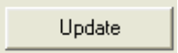 | The Update button updates the tree. This is useful when the user has closed workbooks or sheets.
Content

Exported results: Area Ratio

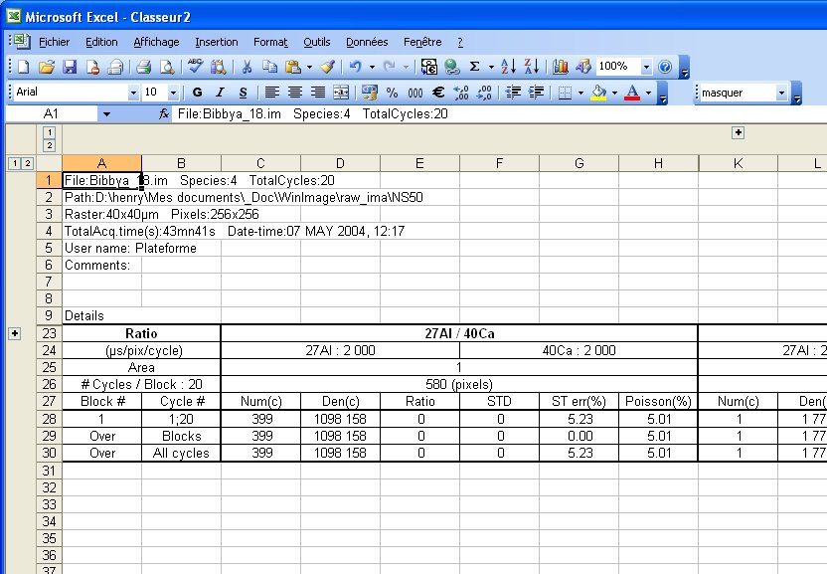
Use the cross to expand exported « Additional data »

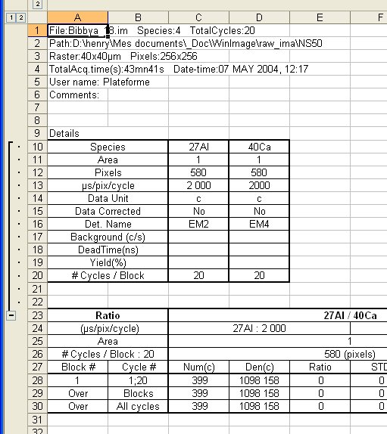
Additional data

Exported results: Depth Profile

When Additional data had been exported, they can be displayed such as for Area Ratio.

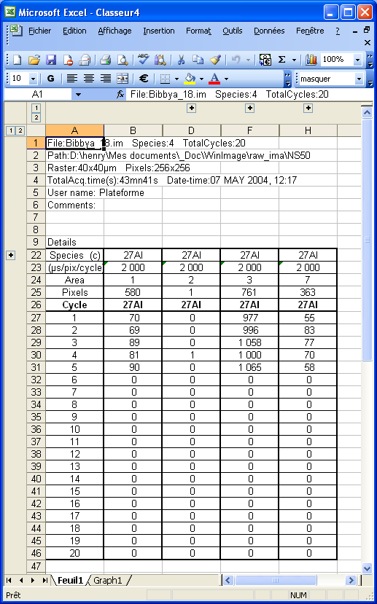 | When exporting Depth Profile results to Excel®, it displays a plot on sheet “Graph1”. To switch to the data results, select “Feuil1”, you will get the table hereunder

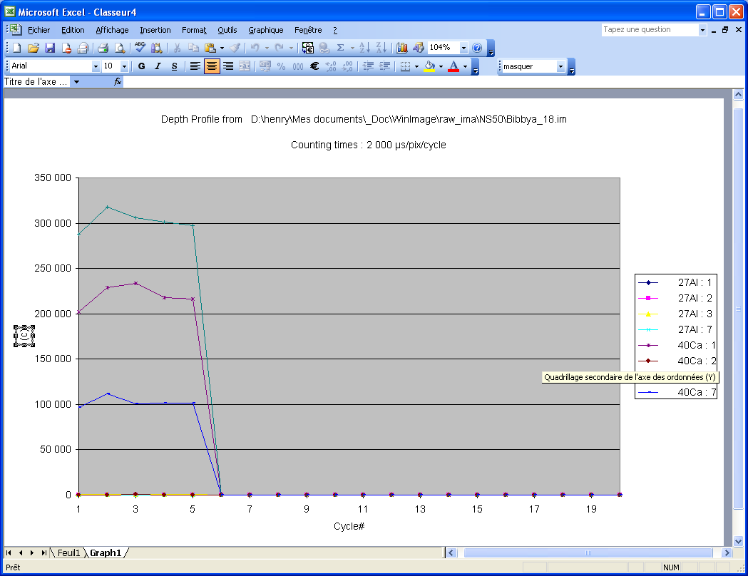

Exported results: LineScan

When Additional data had been exported, they can be displayed such as for Area Ratio.

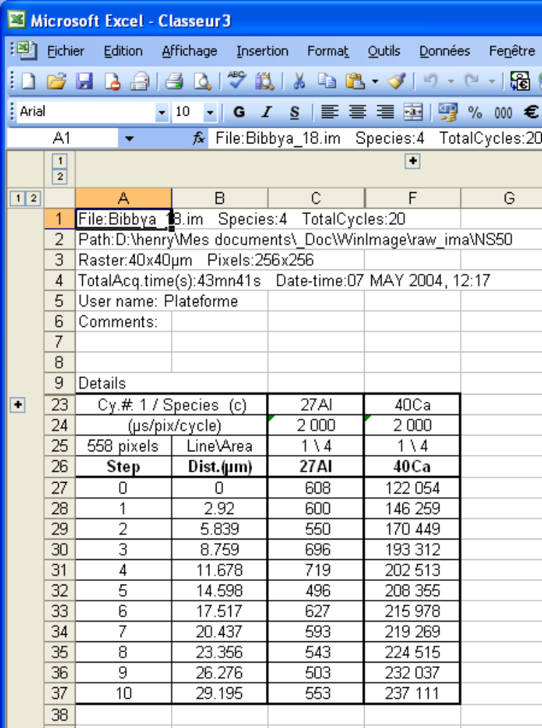 | When exporting LineScan results to Excel®, it displays a plot on sheet “Graph1”. To switch to the data results, select “Feuil1”, you will get the table hereunder

